Observation 1:

After clicking on edit button, in the edit profile page the previously uploaded photo, skills and the company name is not visible.

About me page (after logging with a new user):

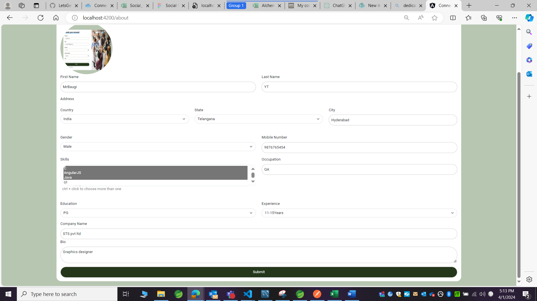

Profile page:

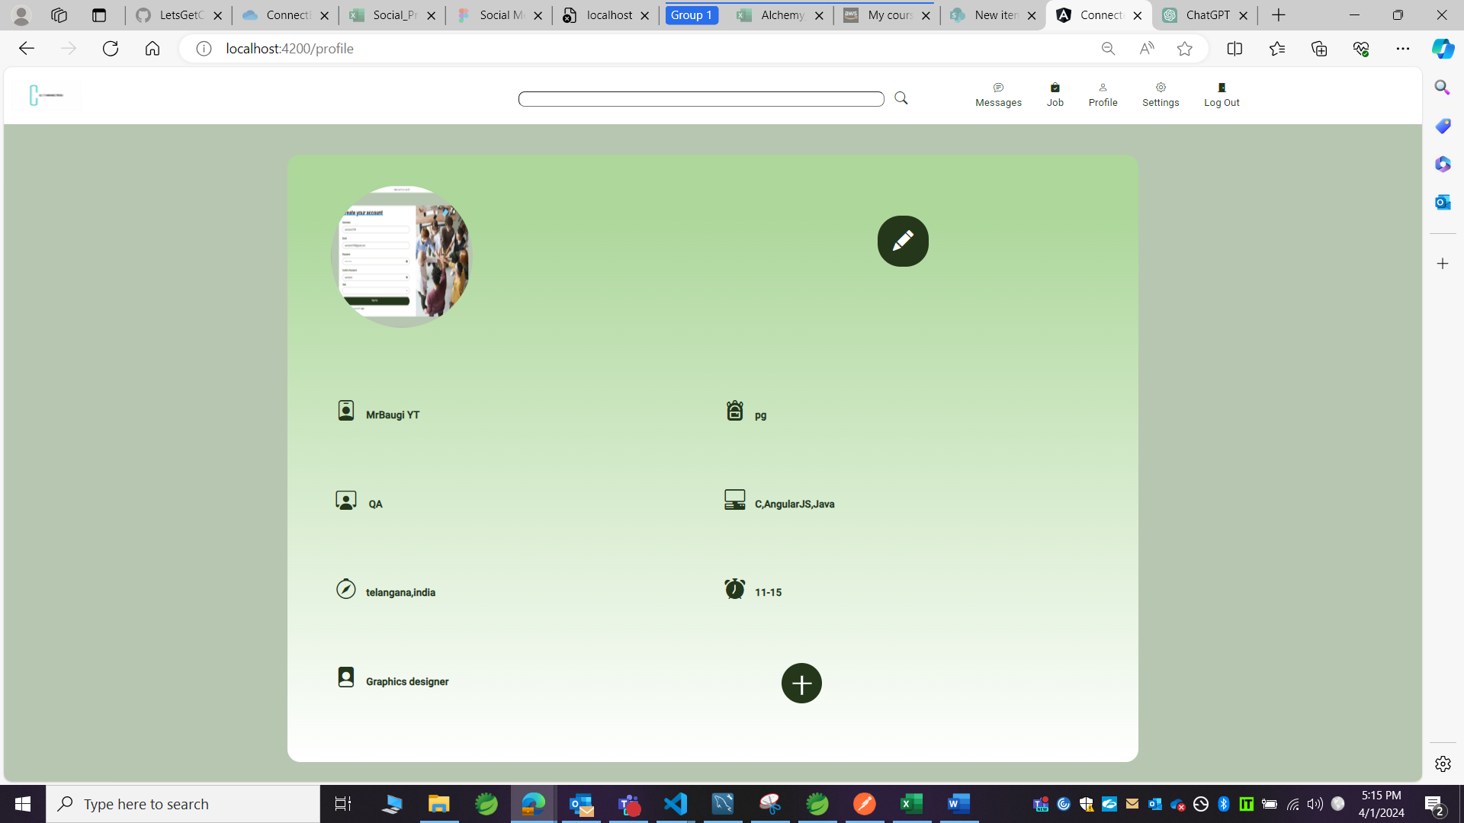

Edit profile page:

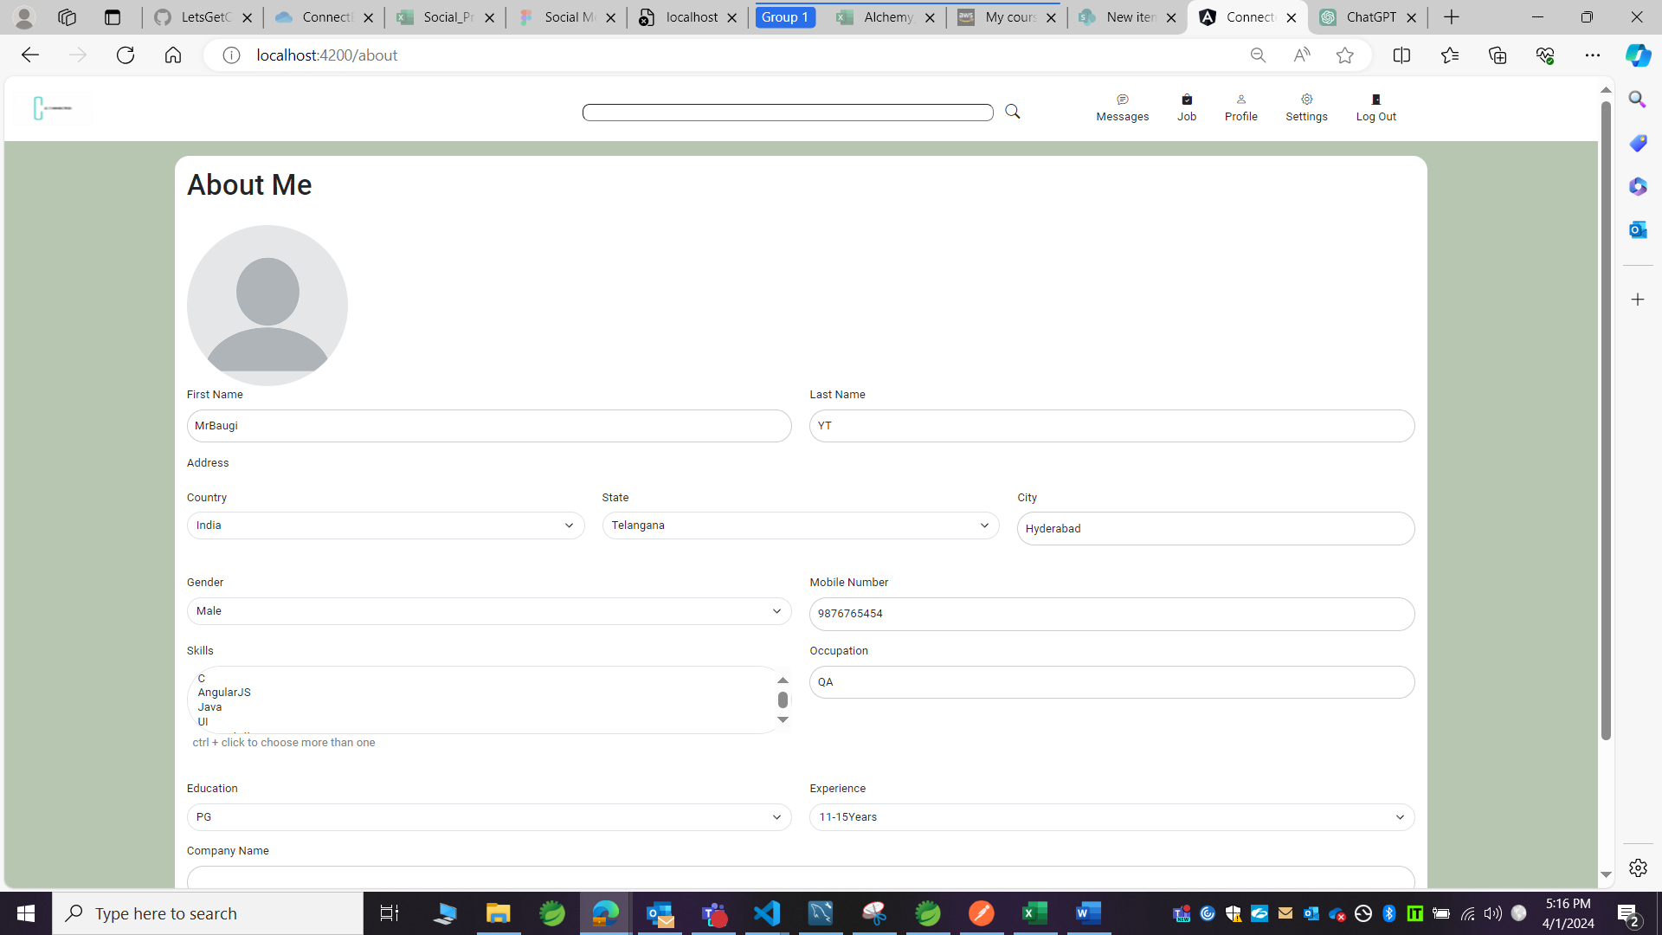

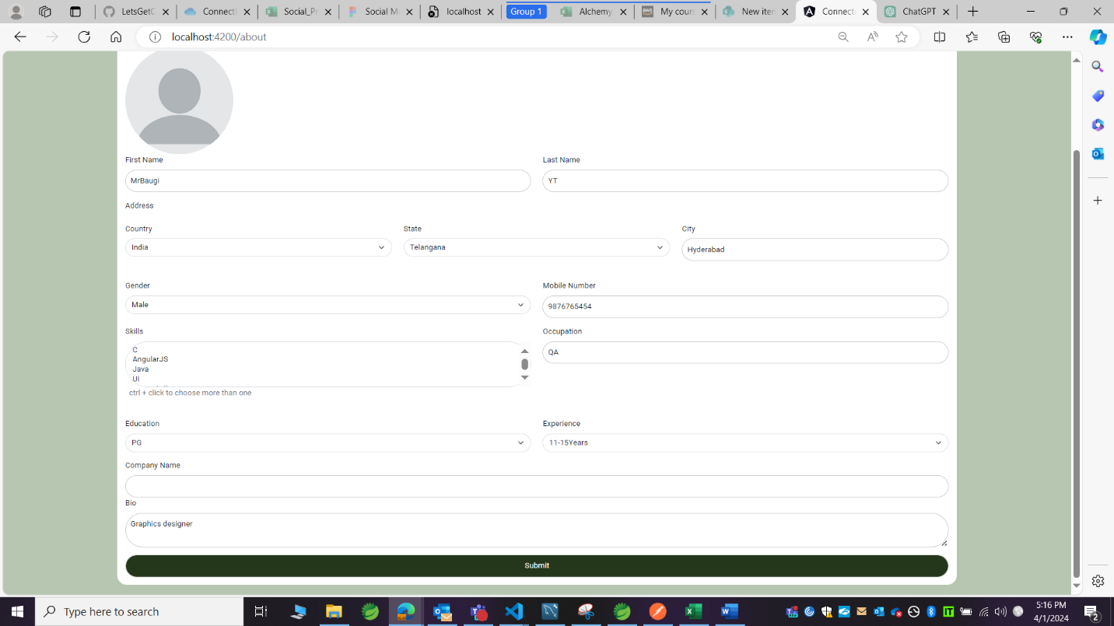

Observation 2:

The icon related to that page is not highlighted, should be highlighted to ensure that we are in that particular page.

Profile page:

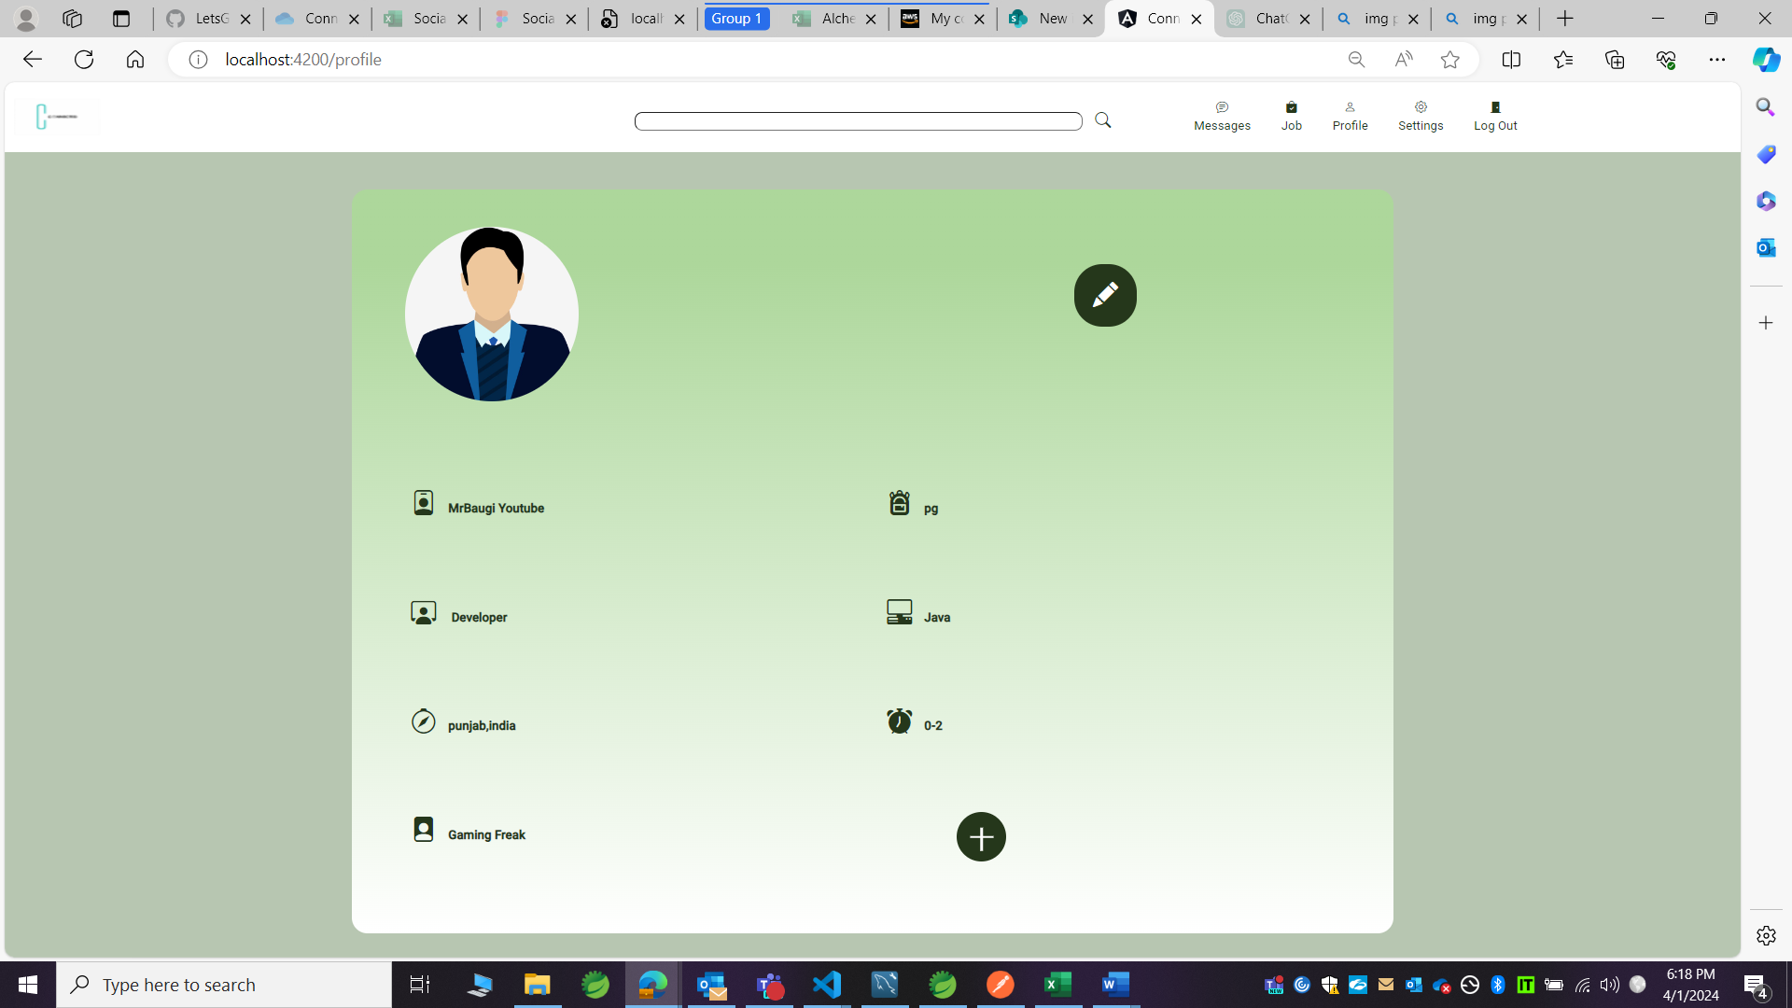

Profile icon not highlighted.

